**Typeface** – Roboto Condensed

Weight – Bold, Light, Regular, Italic

Some of them are used with positive kerning, to give legibility.

I will specify where it has been used ( Will mark on jpeg. )

**Colours** – This is the colour palette

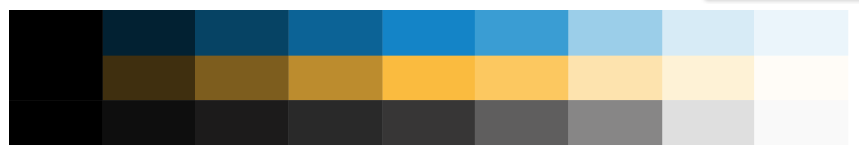

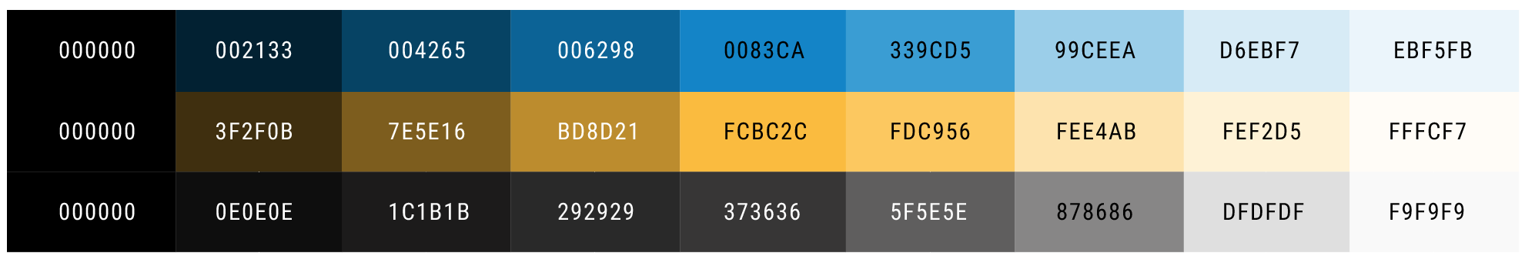

|  |  |  |  |  |  |  |  |  |
| --- | --- | --- | --- | --- | --- | --- | --- | --- |
| 000000 | 002133 | 004265 | 006298 | 0083ca | 339cd5 | 99ceea | d6ebf7 | ebf5fb |
| 000000 | 3f2f0b | 7e5e16 | bd8d21 | fcbc2c | fdc956 | fee4ab | fef2d5 | fffcf7 |
| 000000 | 0e0e0e | 1c1b1b | 292929 | 373636 | 5f5e5e | 878686 | dfdfdf | f9f9f9 |

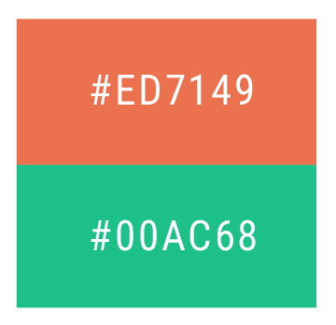

Error Message and boarder **–** Red

Progress bar – Red and Green

Activity Status – Green or Red

#ed7149 **Red**

#00ac68 **Green** ( Used to show Activity only )

**Drop shadows**

All the dropdowns and buttons and error messages will have drop shadows. Please refer the images.

**Dropdown** – Location for drop shadow { x – 0 px, y – 0 px }. Opacity – 20%

**Button** – Location for drop shadow { x – 1 px, y – 1 px }. Opacity – 27%

**Progress Bar –** Location for drop shadow { x – 0 px, y – 0 px }. Opacity – 20%

**Error float message** – Location for Drop shadow { x – 7, y – 7 }. Opacity – 20%

**Font Specifications**

Log in – 14 Regular

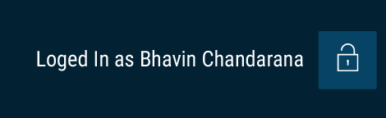

1st Navigation – 15 Regular ( All Caps ) - Hover – Bold



2nd Navigation – 14 Light

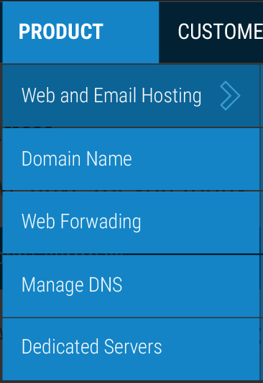

3rd Navigation – 14 Regular

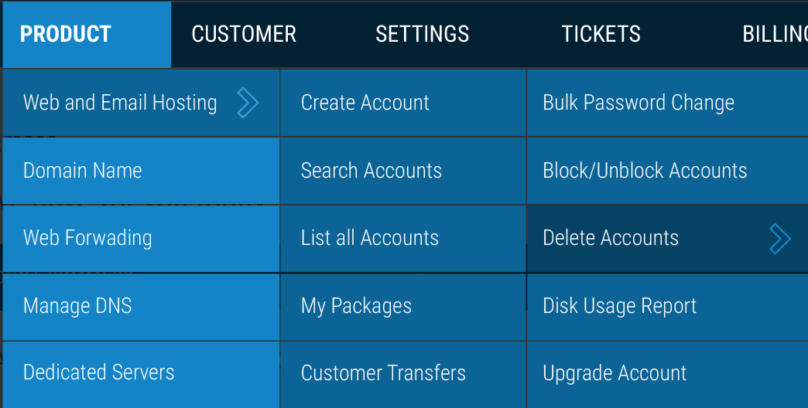

Section Title – 22 Bold



Breadcrumbs – 8 light, active 8 Bold

Macintosh HD:Users:prajaktasarfare:Desktop:Screen Shot 2015-08-10 at 2.10.48 pm.png

4rd Navigation ( Tabs ) - 14 regular ( sentence case )



Page Title – 22 Bold ( Sentence Case )



Page Info – next to page title – 15 Light



**Buttons**

Yellow – 14 bold ( all Caps )



White – 12 Bold

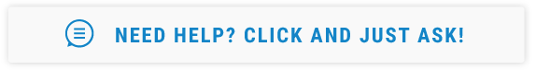

Search Bars and form fills – 14 Light

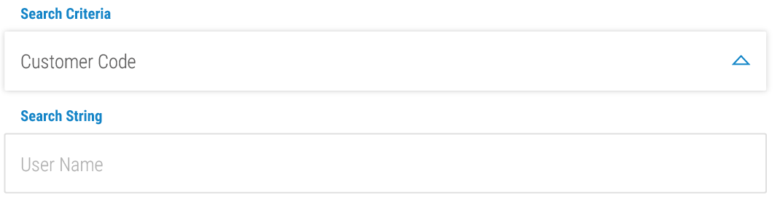

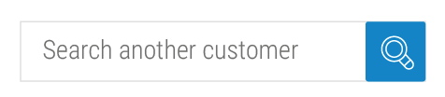

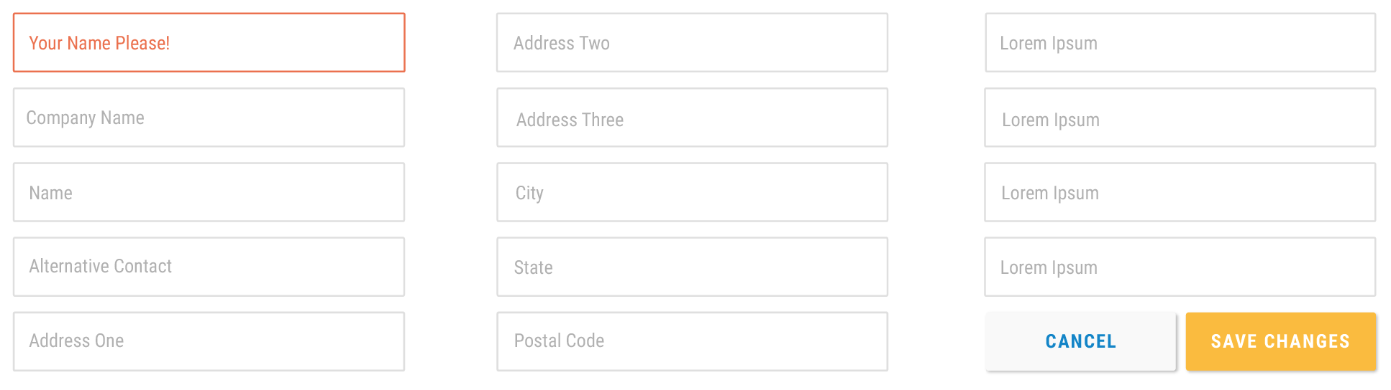

Subtitles ( List headings, form headings ) – 11 Bold

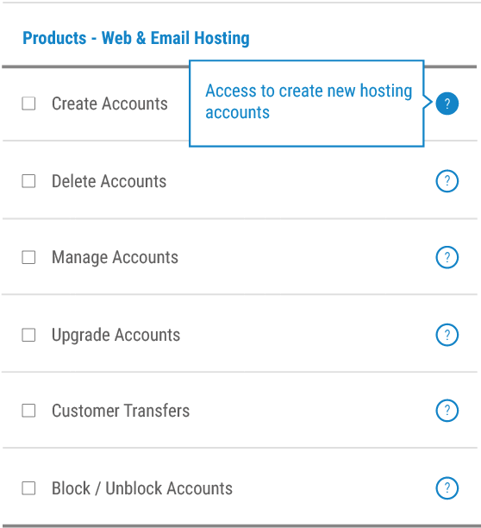

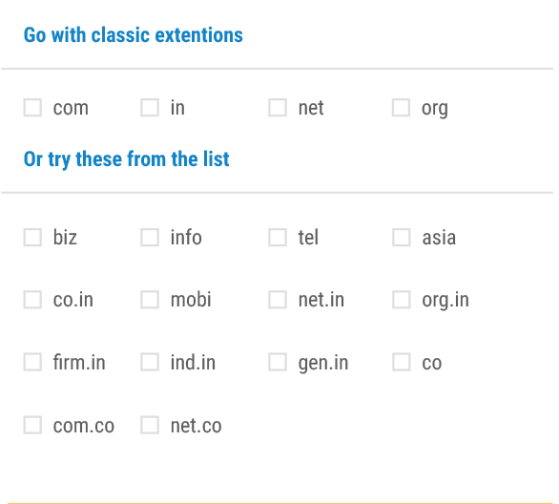

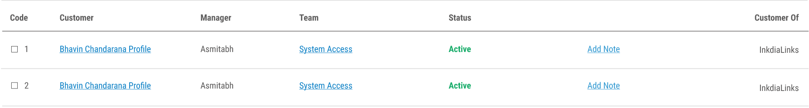

List Items – 11 regular





